6360 Project – Phase 1
Introduction & Background 2
Project Charter / Executive Summary 2
Project Management Framework 3
Project Management Methodology 4
Project Selection Criteria/Model 4
Organizational Alignment 5
Organizational & PM Structure 6
Resolving Resource Conflicts 6
Stakeholder Analysis 7
Cultural Alignment 8
Project Scope of Work 9
Project Priority Matrix (Time–Cost–Performance Trade-offs) 11
Planning & Controls 12
Work Breakdown Structure (WBS) & Coding system 12
Responsibility Assignment Matrix (RAM) & WBS/OBS Integration 13
Communication Plan 14
Estimating & Scheduling 15
Cost Estimation (Macro & Micro) 16
Time Estimation 17
Network Diagram Development 18
Risk & Change Management 18
Risk Management Process 18
Risk Responses & Mitigation Plans 20
Risk Spotlight: Public Opposition 23
Contingency Funds & Time Buffers 23
Change Control Process 24
Conclusion & Next Steps 25
Figure 1 - Network Diagram 26

Tehachapi Renewable Transmission Project – Chino Hills Section

Introduction & Background
California lawmakers recently passed the newest resolution to increase the state’s share of renewable energy consumption to 33% by 2032. As part of this initiative, new renewable energy sources throughout the state need to be identified and developed, harnessing their potential for the long-term benefit of the people of California.
One such source of this renewable energy lies in the Tehachapi Pass, Kern County. This was identified as one of the windiest areas of the state, capable of generating more than 3000 MW of energy. The only issue with this location is its distance from California’s major metropolitan areas. This energy must be transported via high voltage transmission lines to its intended destination. The map below illustrates the approximate route of the transmission lines. (link to source)
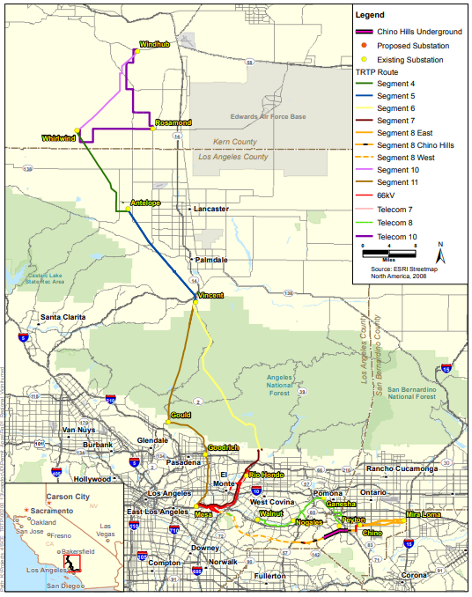
One of the biggest issues with this route lies not with the vast distance between the Tehachapi pass and southern California, but with the particularly tricky stretch of the transmission line stretching east towards SoCal’s inland empire – designation Segment 8 Chino Hills. Following the approval of the project charter below, the project management team at SoCal Edison (SCE) has been tasked with installing this section of transmission lines.

Project Charter / Executive Summary
Business Case:
As part of the Tehachapi Renewable Transmission Project, a section of the transmission lines is required to pass through the city of Chino Hills. This project has two possible routes using existing utilities easements, the option to put the transmission lines above or below ground, and a deadline imposed by the California Public Utilities Commission (CPUC) of 6 years after project initiation due to the state’s 33% renewable energy mandate within 10 years of project initiation. Our company, Southern California Edison (SCE), has been tasked with planning and executing this part of the project.
Brief Project Scope of Work:
For this project, SCE will be required to
- Choose a route for the transmission lines
- Choose whether to run the lines above or below ground
- Construct and install of the necessary components, both structural and functional
- Test, validate, and commission the transmission line
Risk and Spending Limits:
Expenditures are capped at CPUC-approved amounts. Any overruns require executive approval. Budget oversight will be maintained at all stages. Risk tolerance is low. Primary risks include: public opposition, schedule delays, cost escalation, and unforeseen complexity. Mitigation: contingency design reviews, contractor monitoring, and proactive community engagement.
Team Composition and Stakeholders:
The team will consist of a dedicated cross-functional group including members from SCE’s Engineering, Project Management, Construction, Environmental Services, and Community Relations departments. The team will also interface with contractors, vendors, and local agencies as needed. Stakeholders include SCE (Southern California Edison), the City of Chino Hills, California Independent System Operator (ISO), CPUC (California Public Utilities Commission), environmental regulators, and local residents.

Project Management Framework

Project Management Methodology
Due to this project’s nature of having a well-defined end goal and milestones, SCE will be using the Waterfall project management methodology to execute the project. Unlike the Agile methodology, which focuses on iterative processes and breaking up the phases of the project lifecycle, SCE would benefit most from completing each project lifecycle phase in full before moving on to the next.
Project Selection Criteria/Model
To establish the project’s priority within SCE’s portfolio, we applied a Weighted Scoring Model. This approach allowed us to compare multiple initiatives objectively and determine which should receive the highest allocation of resources and management attention. This model combines both qualitative and quantitative factors to ensure that projects deliver not only financial returns but also regulatory compliance, strategic alignment, and stakeholder value.
The criteria used for evaluation were:
- Regulatory Compliance: Alignment with CPUC mandates and federal/state permitting requirements.
- Renewable Energy Focus: Contribution to California’s 33% renewable energy integration goal.
- Core Competencies: Fit with SCE’s established expertise in engineering, construction, and transmission line management.
- Profitability/Cost Reduction Potential: Long-term operational savings, reduced reliance on non-renewable energy, and cost efficiency.
- Urgency: Time sensitivity driven by regulatory deadlines and system reliability requirements.
- Government Subsidies: Availability of external funding or incentives for renewable infrastructure.
- Strategic Alignment: Degree of alignment with SCE’s mission, California’s renewable energy policy, and community needs.
- Project Cost: Overall cost considerations, with higher-cost projects receiving lower scores unless justified by strategic or regulatory needs.
These criteria were applied using a weighted scoring model. Each factor was assigned a weight based on its importance (e.g., Strategic Alignment = 8, Urgency = 7, Profitability = 6), and candidate projects were scored accordingly.
When applied, the Chino Hills 500kV Transmission Line achieved the highest composite score of 184, outperforming other candidates such as the Synchronized Phasor Management System (145) and the Distributed Energy Resource Management System (150).
This confirms that, despite its higher cost and complexity, the Chino Hills project is the optimal choice due to its regulatory necessity, renewable energy contribution, and strategic visibility. The selection model thus ensures resources are allocated where they deliver the greatest long-term value.
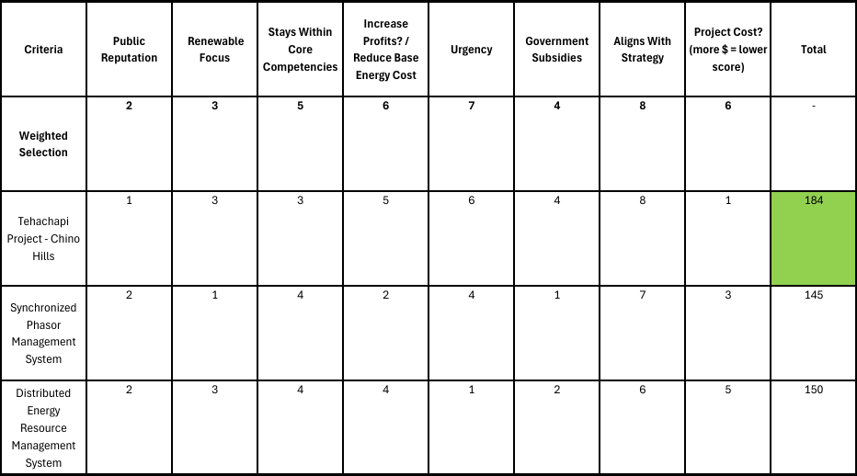

Organizational Alignment
Organizational & PM Structure
The Chino Hills 500kV Transmission Line is being executed under a Balanced Matrix structure. This structure ensures that the project benefits from both centralized leadership and specialized expertise. In this Structure, a dedicated Project Manager is responsible for overall coordination, schedule adherence and stakeholder engagement, while Functional managers (Engineering, Civil Construction, Procurement, Regulatory, and Community Relations) retain technical authority within their respective domains.
This approach is selected because:
- The project requires cross-functional integration across engineering, procurement, construction, and regulatory compliance.
- It is time-constrained, aligning with California’s mandate to achieve 33% renewable energy integration by 2032.
- Strong centralized leadership is needed to manage scope, budget, and schedule, while technical expertise remains within specialized departments.
- Stakeholder oversight from CPUC, the City of Chino Hills, and the community requires both unified project leadership and deep departmental expertise
The Balanced Matrix structure allows SCE to leverage organizational expertise while maintaining the control necessary to deliver the project within the mandated regulatory and schedule constraints.
The organizational design also reflects the diversity of stakeholders involved:
- Internal Core Team: SCE representatives from Project Management, Engineering, Construction, Environmental Services, and Community Relations.
- External Interfaces: Contractors, vendors (e.g., Taihan Electric Wire), and partners such as Black & Veatch for engineering services.
- Key Stakeholders: CPUC and environmental regulators, the City of Chino Hills, local residents, and advocacy groups.
- This alignment allows the project to remain technically rigorous, compliant with regulatory requirements, and responsive to the concerns of external stakeholders.

Resolving Resource Conflicts
One of the main challenges SCE faces from their multi-project focus and balanced matrix structure is conflicting resource demands. The Tehachapi Renewable Transmission Project is a perfect example of this: a program broken up into several similar projects, each with their own unique problems and solutions. Due to their similarities however, separate segments of the transmission line often require the same teams and resources, such as linemen, purchasing staff, heavy construction equipment, and potentially capital.
SCE’s strategy for mitigating these resource conflicts centers around a staggered approach, starting and finishing sections of the program at different times, limiting the number of active projects competing for resources, and allowing lessons learned from earlier sections to be utilized on later, more challenging sections.
This approach also ensures that delays or overruns on any one project have a lower likelihood of endangering the overall project timeframe or budget, as early delays have time to be worked out, resources continue to be utilized during downtime on single projects, and projects with later starts are likely to experience fewer delays as more lessons are applied.

Stakeholder Analysis
Stakeholder Analysis is a technique used in project management to identify and assess the importance, influence, and interest of all individuals or groups who may be impacted by a project or can impact its outcome. Stakeholder engagement has been addressed indirectly through communication plans and regulatory coordination.
These stakeholders are central to the Chino Hills 500kV Transmission Project because the work involves sensitive community, regulatory, and technical dimensions. Their influence determines whether the project proceeds smoothly or faces costly delays.
During this analysis we found that the CPUC, City of Chino Hills, and SCE executives are key players, requiring close engagement, continuous reporting, and active coordination to ensure approvals, funding, oversight, and regulatory compliance. California ISO and environmental regulators hold significant authority but lower day-to-day interest, so they should be kept satisfied with milestone updates and timely compliance documentation. Local residents and community groups, while not holding formal power, have high interest and must be kept informed through transparent communication to minimize opposition. Finally, contractors and vendors fall under minimal effort, requiring only standard updates and performance monitoring. This approach ensures stakeholder expectations are balanced and aligned to support smooth project execution.

Stakeholder | Power | Interest | Category | Engagement Strategy
California Public Utilities Commission (CPUC) | High | High | Key Player | Engage closely; frequent reporting, ensure regulatory compliance, early approval checks.
City of Chino Hills | High | High | Key Player | Active engagement; regular coordination on ROW permits, community relations, local safety.
SCE Executives / Project Sponsor | High | High | Key Player | Continuous updates; involve in cost/schedule oversight, executive approvals for changes.
California ISO | High | Low | Keep Satisfied | Provide milestone updates; engage when grid reliability issues arise.
Environmental Regulators | High | low | Keep Satisfied | Ensure compliance documentation and timely permit approvals; periodic reporting.
Local Residents & Community Groups | High | High | Keep Satisfied | Town halls, newsletters, and transparent updates to minimize opposition and build trust.
Contractors & Vendors | Low | Low | Minimal Effort | Standard contractual updates, progress reports, and compliance checks.

Moving forward, the success of this project will depend on how effectively these stakeholders are managed. Regulatory approvals, budget control, and community relations will shape the project’s trajectory, while contractor readiness will influence schedule reliability. In Phase 2, the team will evaluate how these stakeholder dynamics and consequences affect overall project delivery, with particular focus on cost, schedule, and risk outcomes.

Cultural Alignment
Cultural alignment plays a decisive role in shaping the Chino Hills segment of the Tehachapi Renewable Transmission Project. SCE’s organizational culture emphasizes technical feasibility, regulatory compliance, and cost efficiency—an approach typical of a regulated utility. From this perspective, constructing overhead 500-kV transmission lines is seen as the most rational and economical solution, given its proven technology, lower cost, and shorter construction timeline.
In contrast, the City of Chino Hills and its residents place greater value on aesthetics, safety, environmental protection, and the preservation of property values. This bottom-up, community-driven perspective stands in opposition to SCE’s top-down, utility-first approach. As a result, strong cultural misalignment is creating a rift between SCE and the community.
Despite local opposition, organized protests, and reputational risks, the project is proceeding with CPUC approval in favor of overhead construction. Regulatory feasibility, technological simplicity, faster delivery, and significantly lower costs ultimately outweigh community concerns. While this decision allows the project to move forward efficiently, it also leaves unresolved tensions with the City of Chino Hills and its residents that could manifest as ongoing political or legal challenges in later phases.

Project Scope of Work
Project Objective | Design and construct the Chino Hills segment of the Tehachapi Renewable Transmission Project’s 500kV transmission line. Supports California’s 33% renewable energy mandate by 2032, at a cost of less than $50 million.
Project Scope Description | Energized 500kV transmission lines through Chino Hills that will connect the LA county and San Bernardino County segments of the Tehachapi Renewable Transmission Line. Low impact on the environment.
Justification | California has mandated that SCE increase the share (%) of its energy that comes from renewable sources. The Tehachapi project is meant to increase that share significantly to keep the company within regulatory limits. The Chino Hills segment of the transmission line is the final link needed to bring this renewable energy to SCE’s customer base.
Deliverables | - Pre-project materials  - regulatory approvals and permits  - Route specification  - Tower and grounding system design documents  - Vendor qualifications  - Construction materials  - Constructed towers  - Installed cable  - Final tests  - Documentation
Milestones | - Permits and approvals acquired  - Designs finalized  - Vendors approved and materials acquired  - Sites Prepared  - Towers Constructed  - Cables installed  - Final checks complete
Technical Requirements | - The finished transmission lines must be capable of transmitting 500kW continuously.  - Seismic stability. Transmission will occur over an active fault line.  - Power lines must be a minimum distance apart to prevent arcing, including in high wind scenarios.  - Power lines must be a minimum distance from homes as set by the CPUC.
Limits and Exclusions | Risk tolerance is low. Primary risks: schedule delays, cost escalation, and community pushback/litigation.  Mitigation: contingency design reviews, contractor monitoring, and proactive community engagement.  Expenditures are capped at CPUC-approved amounts of $50 million. Any overruns require executive approval. Budget oversight will be maintained at all stages.
Acceptance Criteria | - Power lines are constructed, installed, and spliced with the next sections of the Tehachapi transmission project.  - Energization tests passed  - Documentation created
Project Priority Matrix (Time–Cost–Performance Trade-offs)
The project uses a Priority Matrix to determine how trade-offs between time, Performance, and cost will be managed. This ensures decisions remain consistent with regulatory mandates, stakeholder expectations, and organizational goals.
- Performance – Constrain: The 500kV transmission line must fully comply with technical specifications, safety standards, and CPUC regulatory requirements. Performance cannot be compromised, as it directly impacts grid reliability and renewable energy integration.
- Cost – Enhance: While the budget is capped at $50M, efficiency and cost control are prioritized. However, limited flexibility is available if overruns are justified and approved by executives or CPUC, ensuring financial discipline without risking project success.
- Time – Accept: The project has a mandated 6-year completion deadline, with an estimated 2-year schedule and a 2+ year buffer. This provides some flexibility to adjust timelines as long as overall delivery remains within CPUC requirements.
Criteria | Priority | Description
Performance | Constrain | Must meet 500kV technical, regulatory, and safety requirements.
Cost | Enhance | Budget efficiency prioritized. While capped at $50M, flexibility is allowed with approvals from Executives.
Time | Accept | Flexible within 6-year CPUC deadline tied to California’s 33% renewable goal, supported by a multi-year buffer.

Planning & Controls
Work Breakdown Structure (WBS) & Coding system
The Work Breakdown Structure (WBS) for this project was created by systematically breaking down the overall scope into progressively smaller, more manageable components. The top-level elements represent the major project phases such as Project Management, Regulatory & Environmental, Prototypes and Designs, Materials Procurement, Site Easement, Cable Installation, and Commissioning & Closeout. Each of these phases was further decomposed into deliverables and work packages. This hierarchical structure ensures that no part of the project scope is overlooked and provides a clear roadmap for planning, scheduling, and assigning responsibility.
WBS coding system follows a logical decimal structure that clearly identifies each level of detail mentioned above. The first digit represents the major deliverable or phase (e.g., 1 = Project Management, 2 = Regulatory & Environmental), while subsequent digits represent sub-levels of work. For instance, 5.1.2 refers specifically to Clearing & grading under Site Preparation (5.1), which falls under Site Easement (5).
This coding method not only organizes the project into distinct components but also creates a standardized system for tracking costs, resources, and schedule performance at multiple levels of detail. By using this hierarchical code, project managers can efficiently manage progress, monitor dependencies, and ensure alignment between deliverables and overall project objectives.
1. Project Management
- 1.1 Issue Project charter
- 1.2 Create Scope of Work
2. Regulatory & Environmental
- 2.1 Regulatory Permits
- 2.2 Environmental Compliance planning
3. Prototypes and Designs
- 3.1 Corridor Identification
- 3.1.1 Route alignment
- 3.1.2 Seismic design & load studies
- 3.2 Civil & Structural Design
- 3.2.1 Footing design
- 3.2.2 Tower structure design
- 3.3 Electrical & Protection Design
- 3.3.1 Cable sizing & specification
- 3.3.2 Grounding system design
- 3.3.3 Relay/protection coordination
4. Materials Procurement
- 4.1 500kV cable procurement
- 4.2 Tower Structural Materials
5. Site Easement
- 5.1 Site Preparation
- 5.1.1 Surveying & staking
- 5.1.2 Clearing & grading
- 5.2 Tower Construction
- 5.2.2 Tower structure construction
- 5.2.3 Tower structure Assembly
6. Cable Installation
- 6.1 Cable Pulling
- 6.1.1 Cable drum delivery & setup
- 6.1.2 Cable pulling operations
- 6.1.3 Cable Splicing
- 6.1.4 Cable Testing
7. Commissioning & Closeout
- 7.1 System Energization
- 7.1.1 Pre-energization checklist
- 7.1.2 Energization testing
- 7.2 Project Closeout
- 7.2.1 As-built documentation
- 7.2.2 Lessons learned Report
Responsibility Assignment Matrix (RAM) & WBS/OBS Integration
The Responsibility Assignment Matrix (RAM) is a tool that integrates the Work Breakdown Structure (WBS) with the Organizational Breakdown Structure (OBS) to clearly define who is responsible for each work package. By mapping deliverables from the previous WBS to the functional units or individuals identified in the OBS, the RAM ensures accountability, eliminates ambiguity, and clarifies roles such as who is responsible, who supports, and who approves each task in this project. This integration allows SCE’s project managers to align the project scope with organizational resources, making it easier to allocate work, monitor progress, and resolve responsibility overlaps or gaps. Ultimately, the RAM provides a structured framework that links project deliverables to the right people, ensuring that all 25 work packages are assigned and managed effectively throughout the project lifecycle.
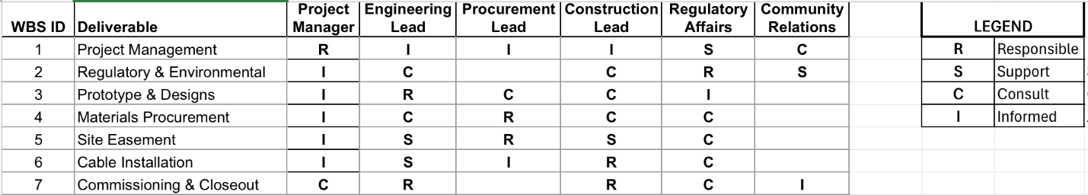
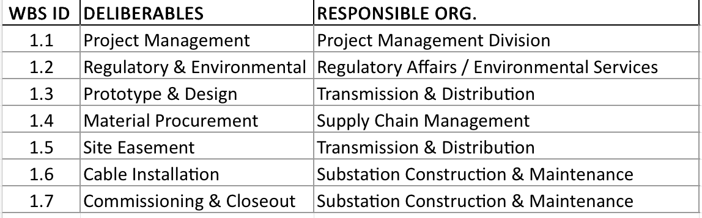
Communication Plan
The communication plan below shows the categories of information SCE is required to disseminate during the course of this project. Much of the communication is internal to SCE. These types of communication are more frequent ensuring that the core team in charge of the project are able to stay abreast of developments within the project.
External communication to vendors is also mandated on a regular basis to ensure project materials are produced and delivered in a timely manner. The goal of these communications is to prevent delays and give SCE the flexibility to change course with ample time should a problem arise.
Conversely, public and regulatory disclosures and comment periods are to be held infrequently or as required by law. While the public’s needs are important to SCE, the company will not unnecessarily run the risk of the project being bogged down by public comment. These communications must be carefully crafted to prevent the present unrest in the public from growing.

What Information | Target Audience | When? | Method of Communication | Provider
Project Proposals for public comment | CPUC, City of Chino Hills, Chino Hills Residents | Prior to choosing route | Town hall meeting | Project Manager, Public Relations
Proposal Decision | City of Chino Hills, Chino Hills Residents, SCE Senior Management | After CPUC has made decision on over heading and route has been chosen | Website Bulletin, Management Meeting | Project Manager, Public Relations
Milestone Report | SCE Senior Management, Project Manager | Bimonthly | E-mail | Department Heads
Project Status Reports and Agendas | CPUC, SCE, applicable vendors | Weekly | E-mail | Project Manager
Department Status Reports | Project Manager | Weekly | E-mail | Department Heads
Issues Report | CPUC, SCE Senior Management | Weekly | E-mail | Project Manager
Vendor Status Reports | Project Manager, Department Heads | Bi-monthly | E-mail | Vendors
Accepted Change Requests | SCE Management, CPUC, Department Heads, applicable vendors | As needed | E-mail | Project Manager
Oversight Decisions | Project Staff, SCE, Project Manager | As needed | CPUC minutes/rulings website pages | CPUC

Estimating & Scheduling
Cost Estimation (Macro & Micro)
Bottom-Up Cost Estimates for this project show that our chosen method of construction will leave SCE well below the $50 million dollar budget. The budget does reveal some interesting insights, however. The construction phases are by far the most expensive (See below cost estimates for details). Over two thirds of the project cost will go towards the materials, site preparation and construction phases of the project. As such, it is important that these phases are well-supported by the preceding activities.
Work Packages | Cost (Micro) ($) | Cost (Mid) ($) | Cost (Macro) ($)
1. Project Management | - | - | $20,000.00
1.1 Project charter | $10,000.00 | $20,000.00 | -
1.2 Scope of Work | $10,000.00 | - | -
2. Regulatory & Environmental | - | - | $125,000.00
2.1 Regulatory Permits | $50,000.00 |  | -
2.2 Environmental Compliance | $75,000.00 |  | -
3. Prototypes and Designs | - | - | $870,000.00
3.1 Corridor Identification | - | $60,000.00 | -
3.1.1 Route alignment | $30,000.00 | - | -
3.1.2 Seismic design & load studies | $30,000.00 | - | -
3.2 Civil & Structural Design | - | $500,000.00 | -
3.2.1 Footing design | $200,000.00 | - | -
3.2.2 Tower structure design | $300,000.00 | - | -
3.3 Electrical & Protection Design | - | $310,000.00 | -
3.3.1 Cable sizing & specification | $40,000.00 | - | -
3.3.2 Grounding system design | $150,000.00 | - | -
3.3.3 Relay/protection coordination | $120,000.00 | - | -
4. Materials Procurement | - | $5,500,000.00 | $5,500,000.00
4.1 500kV cable procurement | $3,000,000.00 | - | -
4.2 Tower Structural Materials | $2,500,000.00 | - | -
5. Site Easement | - | - | $5,050,000.00
5.1 Site Preparation | - | $1,350,000.00 | -
5.1.1 Surveying & staking | $150,000.00 | - | -
5.1.2 Clearing & grading | $1,200,000.00 | - | -
5.2 Tower Construction | - | $3,700,000.00 | -
5.2.2 Tower structure construction | $1,200,000.00 | - | -
5.2.3 Tower structure Assembly | $2,500,000.00 | - | -
6. Cable Installation | - | - | $3,300,000.00
6.1 Cable Pulling | - | $3,300,000.00 | -
6.1.1 Cable drum delivery & setup | $100,000.00 | - | -
6.1.2 Cable pulling operations | $2,500,000.00 | - | -
6.1.3 Cable Splicing | $600,000.00 | - | -
6.1.4 Cable Testing | $100,000.00 |  | -
7. Commissioning & Closeout | - | - | $450,000.00
7.1 System Energization | - | $250,000.00 | -
7.1.1 Pre-energization checklist | $150,000.00 | - | -
7.1.2 Energization testing | $100,000.00 | - | -
7.2 Project Closeout | - | $200,000.00 | -
7.2.1 As-built documentation | $150,000.00 | - | -
7.2.2 Lessons learned Report | $50,000.00 | - | -
Total |  |  | $15,315,000.00

Time Estimation
Time estimation in project management is the process of predicting the duration required to complete individual tasks, work packages, and the overall project. It helps establish realistic schedules, identify the critical path, allocate resources effectively, and assess whether the project can be delivered within mandated deadlines. Time estimates are crucial because they directly influence cost, scope, and resource planning, and they form the foundation of the project schedule and risk management processes.
For the Chino Hills 500kV Transmission Line, we applied a bottom-up approach, starting by assigning each work package a duration in days using expert judgment and reference to similar past projects. The resulting estimate of 1,195 days (around 3.3 years) provides the baseline timeframe for the project (not factoring concurrency) and will guide critical path analysis and deadline management against CPUC’s requirements.
To get a more accurate project duration we must look at the network diagram in the next section.

Network Diagram Development
In developing the project network of 25 work packages, the activities and their dependencies were arranged into a logical sequence. This analysis showed that the project has two critical paths, with one of the sequences being:
1.1–>1.2–2.1–>3.1.1–>3.3.2–>4.1–>4.2–>5.1.2–>6.1.1–>6.1.2–>7.1.1–>7.1.2–>7.1.2–>7.2.1–>7.2.2.
To identify these paths, forward and backward passes were performed to calculate early and late start/finish dates. The late finish value was set at the six-year imposed deadline for the project. From this, the total slack for each work package was derived. Total slack indicates how long an activity can be delayed without pushing back the overall project finish, while free slack measures how long an activity can be delayed without affecting the early start of its immediate successor.
The results showed that the activities on the two critical paths had the least amount of total slack (1,509 days), meaning they directly control the project’s completion time. Importantly, while many activities across the network exhibited high total slack, very few had substantial free slack. This means that even if the overall project deadline appears safe, most activities cannot slip without directly affecting their successors.
This condition makes the project highly sensitive meaning a small delay on one of the near-critical paths could easily consume the limited buffer and push that path onto the critical list. Because there are multiple critical paths, the risk is magnified: several sequences of activities must be tracked and managed in parallel. Recognizing the difference between free and total slack in the network and paying close attention to paths that are “nearly critical” underscores the need for proactive schedule control, contingency planning, and close coordination across all 25 interconnected work packages.
See the network diagram at the end of the report.

Risk & Change Management
Risk Management Process
Risk management is the systematic process of identifying, assessing, and responding to uncertainties that could affect a project’s objectives. It ensures potential threats are addressed before they escalate and opportunities are leveraged when possible. Effective risk management is critical because it reduces delays, controls costs, improves safety, and builds stakeholder confidence. In large-scale infrastructure projects such as the Chino Hills section of the Tehachapi Transmission Line project where regulatory, technical, and community issues intersect, structured risk management is essential to project success.

The process typically involves:
- Identification – Listing potential risks across technical, regulatory, financial, and stakeholder dimensions.
- Assessment – Evaluating risks based on probability and impact to prioritize the most critical.
- Ownership – Assigning responsibility to individuals or teams best positioned to manage each risk.
- Response Planning – Developing strategies to avoid, mitigate, transfer, or accept risks.
- Monitoring – Tracking risks throughout the project lifecycle to adjust strategies as conditions change.
Risk ID | Risk Description | Cause/Source | Owner
R1 | Public opposition or protests | Community concerns over safety, EMF exposure, noise | Project Manager/  Community Relations
R2 | Delay in CPUC approval | Delay in review, missing documentation | Regulatory Affairs
R3 | Environmental non-compliance | Dust, noise, wildlife disruption and potential hazardous material spillages. | Regulatory Affairs
R4 | Vendor supply chain delay | Vendor qualification delays, long lead times for 500kV cables & tower materials | Procurement Lead
R5 | Cable splicing or testing failure | Design Errors, Workmanship issue (Flaws in the engineering of the system, such as incorrectly sized equipment, insufficient structural capacity for towers, or incomplete drawings) | Engineering lead/Procurement lead
R6 | Construction complexity & unforeseen ground issues | Seismic faults, soil instability, access challenges | Construction Lead
R7 | Worker injury or accident | High-voltage handling, heavy equipment | Construction Lead
R8 | Budget overrun | Underestimated costs, scope creep | Project Manager
R9 | Ineffective stakeholder communication | Misalignment between CPUC, city, contractors | Project Manager
R10 | Extreme weather impacts | Heavy rain, heat waves | Construction Lead
R11 | Labor strikes or shortage | Union disputes, lack of skilled cable jointers | Procurement Lead
R12 | Seismic Activity | Earthquakes occur in the area frequently. Earthquakes of sufficient size to cause damage or risk to the project, however, are rare. | Accept

Probability / Impact | Low | Medium | High
Unlikely |  |  | R12
Moderate |  | R3,R7,R8,R11 | R4,R5,R6
Very Likely | R10 | R2 | R1,R9

Risk Responses & Mitigation Plans
A risk response plan defines how the project will deal with risks—whether by avoiding them, mitigating their impact, transferring responsibility, accepting them, or escalating them to higher authorities. A mitigation plan focuses on the concrete actions taken to reduce the likelihood or impact of a risk.
For the Chino Hills 500kV Transmission Line, risk responses and mitigation plans were applied across several high-priority areas:
- Public Opposition or Protests – Mitigated by proactive stakeholder engagement, regular communication with residents, and escalation to senior management when issues intensify.
- Delay in CPUC Approval – Mitigated by submitting complete documentation early, maintaining close follow-up with regulators, and addressing feedback promptly.
- Environmental Non-Compliance – Managed through mitigation: routine environmental audits, dust/noise control, and wildlife protection measures during construction.
- Vendor Supply Chain Delays – Addressed by mitigating the risk through qualifying multiple suppliers, tracking vendor milestones, and diversifying procurement options.
- Cable Splicing or Testing Failures – Mitigated through design peer reviews, strict quality assurance testing, and backup procedures to reduce downtime if failures occur.
- Construction & Ground Challenges – Escalated to engineering leadership, with mitigation through detailed geotechnical studies and flexible construction sequencing.
- Worker Safety – Mitigated and partially transferred via strict safety training, PPE enforcement, and contractor insurance requirements.
- Budget Overrun – Escalated to senior management for oversight and mitigated by applying earned value analysis to track deviations early.
- Stakeholder Communication Gaps – Escalated through regular reporting and mitigated with structured communication plans and bi-weekly coordination meetings.
- Extreme Weather – Mitigated by seasonal planning, schedule adjustments, and monitoring weather alerts.
- Seismic Activity – Accepted as a rare but possible event; mitigation includes staff safety training, emergency protocols, and preparedness planning.
Analysis | Monitoring | Response  Strategy | Strategy
High likelihood of community pushback; could cause major schedule delays. | Weekly - Track community complaints, monitor media & social platforms | Mitigate and Escalate | Escalate to Senior Management / Local Government -Resolve disputes where possible and maintain project continuity if community pressure escalates
CPUC delays are common; impacts project start date. | Bi-Weekly - Review permit approval status, direct CPUC updates | Mitigate | Submit complete docs early, follow up regularly, monitor CPUC status
Regulatory fines possible, but impact contained if monitored. | Weekly - Site inspections, environmental audit reports | Mitigate | Regular site inspections, environmental audits, dust/noise control, wildlife monitoring
Any delay in getting materials to the work site delays the project completion date | Weekly - Vendor delivery reports, milestone tracking | Mitigate / Transfer | Track vendor milestones, maintain multiple suppliers, order long-lead items early. Transfer to Vendors (via contractual obligations with penalties)
Unlikely, potential to be highly disruptive if not caught during testing | Per Test Cycle - Quality control tests, engineering signoffs | Mitigate & Accept | Quality control tests, design peer review, backup components ready. Be prepared for Minor failures absorbed within testing schedule
Soil instability and seismic risks significant in Chino Hills. | Daily Before starting the construction and weekly once the construction is started | Escalate | Senior Project Manager / Engineering Director - Geotechnical surveys, adjust construction methods, worker training
High safety risks involved with working with high voltage cables and heavy machinery; accidents could halt work temporarily. | Daily - Safety incident reports | Mitigate/  Transfer | Minor incidents can occur, Enforce PPE, safety drills, daily safety reporting, accident insurance
Contingency planning required; scope creep is a concern. | Monthly - Cost variance reports, earned value tracking | Escalate /Transfer | Senior Management - Track costs, control scope creep, review contracts. Transfer financial risk to contractors through fixed rate contracts and the government through budget increase clauses for mutually agreed changes in project requirements or expansions of scope.
Misalignment can cause rework and delays. | Bi-weekly - Meeting minutes, communication dashboard | Escalate | Escalate to Senior management to keep the project completion on track
Weather events are likely but can be planned for. | Seasonal - Weather alerts, contingency planning checks | Mitigate | Contingency plans for weather, flexible schedule, monitor alerts
Workforce availability risk due to union disputes. | Monthly - Based on union negotiations status | Transfer | Maintain buffer workforce, cross-train staff, negotiate labor agreements
Seismic events are unpredictable but rare. | Weekly - Check recent seismic activity for upticks in frequency and intensity as these could indicate increased likelihood for a major seismic event. | Accept | Keep all staff aware of safety protocols necessary for major seismic events, prepare emergency preparedness plans for each work site along the route

Risk Spotlight: Public Opposition
For the Chino Hills section of the Tehachapi Renewable Transmission Project, the risks posed by public opposition have been clear from the start. As covered in the cultural (mis)alignment section, the residents of Chino Hills are displeased to have large transmission towers constructed near their homes. It is possible that even with the CPUC’s approval pushback from this source could turn into a larger problem for the project, with possible consequences being forced rerouting of the segment, or forced undergrounding of the transmission lines. This could be considered a complete reset of the project back to the prototyping phase.
The CPUC approval for overheading the lines was a major step towards mitigating the risks of public opposition and the completion of the Chino Hills section of the Tehachapi Renewable Transmission Project. These approvals give SCE legal authority to continue with the planned overheading of the transmission lines. Even should the CPUC revoke this decision, SCE will now be able to demand compensation for increased costs accrued.
Despite this major step forward, the risk of a CPUC reversal in response to public opposition is possible, if unlikely. To avoid the outcome of a CPUC reversal, continued steps will need to be taken. SCE plans to:
Continue to hold community outreach meetings at the Chino Hills City Hall
Continue lobbying with the CPUC
Continue to engage in compensation talks with the city of Chino Hills, specifically regarding compensation for lower housing prices in affected areas.
It is expected that between these mitigation steps, SCE will be able to prevent public outcry from reaching levels that sway the overheading decision of the CPUC and thus, keep the Chino Hills section of the Tehachapi project on track.

Contingency Funds & Time Buffers
Despite their comparatively low cost, the early stages of this project hold an outsized influence over the project’s success. These estimates reveal that should pre-project planning or prototyping fail in their tasks of preventing design flaws or revealing major project changes before construction costs are realized, the total costs of the project could balloon. Thus, more time needs to be held in contingency for these sections to ensure we have the flexibility needed to ensure success in the planning stages.
Similarly, greater contingency funds are allocated toward the construction phases of the project to buffer any cost overruns that may occur due to the likelihood that problems found in these sections will cost more money than the rest.
Another theme of the risks is a measured response to uncontrollable or unlikely events such as weather, injuries, or earthquakes. We can plan for the likely outcomes of these events by either building in time for weather delays or allocating money towards insurance or recovery efforts when these events occur.
Risk ID | Time Buffer | Contingency Funds
R1 | 2 years | 10,000,000
R2 | 9 months | $200,000
R3 |  | $400,000
R4 | 6 months
R5 | 3 months | $200,000
R6 | 3 months | $400,000
R7 |  | $2,000,000
R8 |  | Management Funds
R9 | 3 month | $500,000
R10 | 10 months | $1,,500,000
R11 | 3 months | $2,000,000
R12 |  | $1,000,000
 | Management Funds for Project | $8,200,000

Change Control Process
The change control process will be controlled through a change control database application which will keep track of the following:
- Unique change request IDs
- Description of the Change Request
- Status of the Change Request
- Date the request was opened
- Date the request was last updated
- Date the request was closed/completed
- Date request must be decided on (if applicable)
- Approximate Cost of the change
- Approximate delay caused by the change
- Who requested the change
- Who is assigned to bring the request through to closure/completion
- Comments on the change
- Relevant documents to the requested change
- Priority of the change
- Proposed funding source
- Reason for the change
- Approvals
Every change will need to be approved first by the functional manager of the department responsible. The request will then be moved to the project manager to filter and prioritize projects. They will then be routed to the management of SCE stakeholders (CPUC, city of chino hills, appropriate vendors), before finally being approved for closure/completion by the project manager after integration with the overarching project.
This database will have an interface available to as many SCE employees and managers engaged on this project as possible, managers, vendor representatives, and stakeholder representatives to enter change requests.

Conclusion & Next Steps
In Phase 1, we established the foundation for the Chino Hills 500kV Transmission Project by defining the business case, project charter, and regulatory drivers. We adopted a Balanced Matrix structure to combine centralized leadership with specialized expertise. Key planning deliverables were completed, including the priority matrix, WBS, RAM, cost and schedule estimates, network diagram, communication plan, and a comprehensive risk register with defined mitigation strategies. Moving forward, we will focus on putting these risk management strategies in practice, monitoring their effectiveness, and integrating them into project execution to ensure strong oversight, stakeholder alignment, and compliance with CPUC’s renewable energy mandate.

Figure 1 - Network Diagram
